Automation Step by Step
AUTOMATION | TESTING | DEVOPS | CI
MENU

Tag «raghav pal»

Docker Beginner Tutorial 1 – What is DOCKER (step by step) | Docker Introduction | Docker basics
December 31, 2017Automation, CI, DevOps, DockerComments: 0

Notes: Today we will learn: What is Docker ? Docker is the world’s leading software container platform Docker makes the process of application deployment very easy and efficient and resolves a lot of issues related to deploying applications Docker is a tool designed to make it easier to deploy and run applications by using containers …
Read more

Selenium Beginner 15 – How Selenium interacts with PhantomJS
December 30, 2017Automation, Selenium, TestingComments: 0
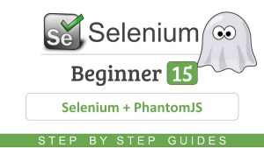
Notes: Recommended – How to use PhantomJS (Headless Browser) Today we will learn : 1. What is PhantomJS 2. How Selenium interacts with PhantomJS Helpful TIPS interview section.. Pros and Cons of PhantomJS 1 What is PhantomJS PhantomJS is an open source Headless Browser. (It is a web browser without graphical user interface) It is …
Read more

Selenium Beginner 14 – How to use PhantomJS (Headless Browser)
December 30, 2017Automation, Selenium, TestingComments: 0
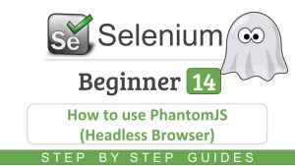
Notes: Recommended – How Selenium interacts with PhantomJS Today we will learn : 1. How to download PhantomJS 2. How to add in selenium project 3. How to run selenium test on PhantomJS How to download PhantomJS Step 1 Download phantomJS for your OS http://phantomjs.org/download.html Step 2 (optional) Download PhantomJS Driver Not Required with latest …
Read more

Selenium Beginner 13 – How to use HtmlUnit Driver
December 30, 2017Automation, Selenium, TestingComments: 0
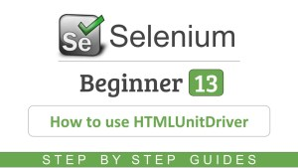
Notes: Pre-requisites – Selenium jars should be added to the project. This is covered in the earlier session on this series. Selenium Beginner 5 – How to write first Selenium script (java) – 5 Easy Steps Today we will learn : 1. What is HtmlUnit Driver 2. How to run test with HtmlUnit Driver HtmlUnitDriver …
Read more

Selenium Beginner 12 – What are Headless Browsers
December 30, 2017Automation, Selenium, TestingComments: 0
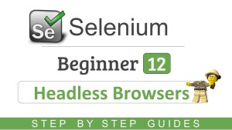
Notes: Today we will learn: 1. What are Headless Browsers 2. Why should we use Headless Browsers 3. When should we NOT use Headless Browsers 4. Examples of Headless Browsers Helpful TIPS Html Unit browser PhantomJS TrifleJS SlimmerJS ZombieJS References: Headless Browsers list – https://gist.github.com/evandrix/3694955 Xvfb wikipedia – https://en.wikipedia.org/wiki/Xvfb Xvfb Jenkins Plugin – https://wiki.jenkins-ci.org/display/JENKINS/Xvfb+Plugin Stack …
Read more

Selenium Beginner 10 – How To Use Config Properties File
December 30, 2017Automation, Selenium, TestingComments: 0
Notes: Today we will learn: 1. What is a properties file 2. How to create a properties file 3. How to get data from properties file 4. How to set data to properties file 5. Run test using Properties file Helpful TIPS _______________________________________________ How to get data from properties file STEP 1: Create a object …
Read more

Selenium Beginner 9 – How To Make Code MODULAR
December 30, 2017Automation, Selenium, TestingComments: 0
Notes: Today we will learn: 1. How to identify actions 2. How to make code modular _____________________________ Step 1: Create methods for separate actions/functionality Step 2: Copy required code from main to these methods Step 3: Call the methods from main in required sequence Step 4: Run and Validate Helpful Tips: 1. Create a separate …
Read more

Selenium Beginner 8 – How to run test on Chrome Browser
December 30, 2017Automation, Selenium, TestingComments: 0
Notes: Today we will learn: Step 1 – How to download ChromeDriver Step 2 – How to set ChromeDriver in System Properties System.setProperty(“webdriver.chrome.driver”, “location of chrome driver executable”); WebDriver driver = new ChromeDriver(); Step 3 – Run test in Chrome Browser helpful tips | interview section References : Selenium HQ – http://www.seleniumhq.org/ ChromeDriver exe release …
Read more

Selenium Beginner 6 – How To Use Selenium 3 – Gecko Driver
December 30, 2017Automation, Selenium, TestingComments: 0
Notes: Today we will learn: 1. How to add Selenium 3 Jars 2. How to add gecko driver 3. Run test with Selenium 3 helpful tips interview section References – Webdriver interface documentation – http://seleniumhq.github.io/selenium/docs/api/java/ Selenium HQ – http://www.seleniumhq.org/ Gecko Driver Download – https://github.com/mozilla/geckodriver/releases Selenium YouTube Playlist Send me your comments and feedback
Read more

JMeter Beginner Tutorial 25 – Jmeter How to record login test
November 5, 2017Automation, JMeter, Performance TestingComments: 0
Notes: Step 1 : add blazemeter plugin to chrome browser Step 2 : start blazemeter plugin and login to blazemeter Step 3 : Record your scenario – Stop Recording – Export .jmx In case you find jmx option disabled export as json and use this link to convert to jmx http://converter.blazemeter.com/ Step 4 : Import …
Read more

